Final Examination

College of Engineering, IT and Environment

|  |  |  |
| --- | --- | --- |
| **HIT164-Computing Fundamentals - Special** | **DURATION** | |
| Reading Time: | 10 minutes |
| Writing Time: | **120** minutes |
| Scanning and uploading: | 20 minutes |
| **INSTRUCTIONS TO CANDIDATES** | | |
| Notes:  1. Read all questions carefully.  2. Answer all questions.  3. Total marks available on this test are 50.  4. Questions are (not) of equal value.  5. Open book exam.  6. Email the answers to Bharanidharan.shanmugam@cdu.edu.au | | |
| **EXAM CONDITIONS** | | |
| **You may begin writing from the commencement of the examination session.** The reading time indicated above is provided as a guide only. Please make sure that you submit your work on time. | | |
| This is an OPEN BOOK examination | | |

**Question 1**

The Australian Computer Society lists several responsibilities in its Code of Ethics. One of which is “Professionalism”. Discuss this imperative and provide at least one example in your discussion. (The example may be real, hypothetical or fictitious)

There is a requirement for professionals within the ICT industry to conduct themselves at or above an expected standard of professionalism. Firstly, this includes treatment of other people, whether they be clients or co-workers; specifically relating to discrimination, bullying and harassment etc. This expectation is common to all workplaces and environments; however the ACS expects that its members take and active and informed approach to improving diversity and hinder any others’ efforts to limit diversity or opportunity in the workplace.

ACS also expects that people inform boarded society on the activities and information available regarding ICT and communicate with others in order to advance cooperation within ICT. This is done through professional societies and events to advertise ICT capabilities and can also be done through education programs or seminars to targeted groups, such as students to allow the next generation of ICT leaders a greater understanding before choosing career paths.

(Marks: 10)

**Question 2**

Draw a circuit diagram using the following online tool for the formula : F(output)=a’b+c

**logic.ly/demo**

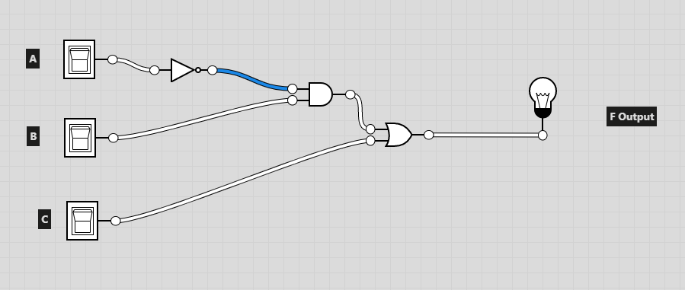

(Marks: 05)

**Question 3**

Explain the output of the following HTML code

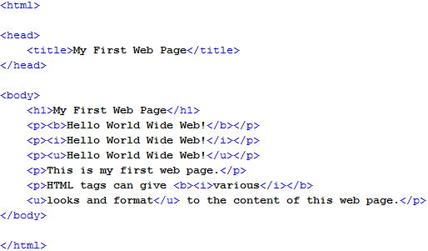

Page title will be “My First Web Page”

The header will be in the default h1 unless a CSS has been applied with the text “My First Web Page”

The first line will be in bold with the text “Hello World Wide Web!”

The second line will be italicised with the text “Hello World Wide Web!”

The third line will be underlined with the text “Hello World Wide Web!”

The next line of text will be “This is my first web page.” Default text formatting will apply.

The next line of text will be “HTML tags can give ***various***looks and format to the content of this web page.” That is, “various” is bold and italicized and “looks and format” is underlined.

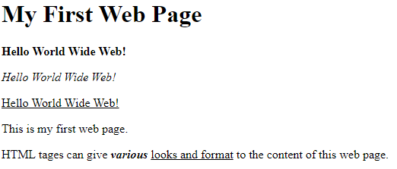

(Marks: 10)

**Question 4**

When building simple websites, there are a range of practices you should follow. Outline three important practices when coding your own website. (Marks 05)

* Format of the website and all pages should follow a similar format and colour scheme.
* Displays and information should be simple and provide the minimum amount of information necessary to the user. If excessive or unnecessary information is displayed or forced onto the user, important information is lost and the user can become confused or overloaded.
* Code should be maintained in a simple, coherent and consistent method so that errors, issues or changes can be amended easily. This can be done through the use of CSS or template sheets, which will aid in amending the format to all pages at once, maintaining consistency throughout pages. This also helps if others are required to read, check or edit the code.

**Question 5**

Explain Blockchain with a neat diagram.

Blockchain provides a secure method of communicating information, most famously cryptocurrency, from one peer to another with the reduced chance of interference from others.

This is done through Nonce – number only once, is used to validate a hash.

The hash is a series of numbers and letters that can only be used for the data and index it is for. If the data changes the hash changes. The Hash is the same length.

When the data is “mined” the next block in the chain requires the previous hash and creates a new hash for that piece of data.

Each data block can only refer to the previous or subsequent block in the chain and no others.

Index - 1

No Prev Hash

Hash

Index – 2

Prev Hash

New Hash

Index - 3

Prev Hash

New Hash

(05 Marks)

**Question 6**

CSS is a way of separating out style from content. Can you explain why you need to do this?

Using a Cascading style sheet (CSS) provides a layout or structure for HTML and XML. It also can change the default settings for text, paragraphs, headings etc. so that they are not the standard default HTML format. The use of CSS allows for consistency across a number of pages that use the same CSS template or external html file. This also allows for changes to be made in one location for the entire webpage, rather than in multiple locations. It also allows for errors to be fixed in this single location.

(05 Marks)

**Question 7**

Explain the application areas of SharePoint with an example for each.

Collaboration – through SharePoint users, with the appropriate access, can upload and edit files that others have access to, who can also edit and those files, in most cases, simultaneously.

Content management – through various methods of access control, users can have access specific to their roles or requirement to see certain information. This can also be unlimited so that all users can have all levels of access, however this is likely to create issues with document control and deletion of users and files. Content version control or monitoring is also featured in SharePoint, allowing users to view edits to documents and retrieve deleted files.

Access control – administrators can control access for users and their ability to invite and give access to others. This

Office applications – other office365 applications are enabled for use within SharePoint which allows for greater flexibility within an organisation to create and edit files, as well as using all other Office365 business related applications.

(4 Marks)

**Question 8**

Complete the following table without using calculators.

(6 marks)

|  |  |  |
| --- | --- | --- |
| (18)10 | (22)8 | (12)16 |
| (110011111)2 | (637)8 | (19F)16 |
| (10011110111)2 | (2370)8 | (4F8)16 |

!End!